**Practical-4**

1. Write a program to create a Class named ATM having following methods which performs ATM transaction:

Balance_check():- To Check the balance of Current Account

Debit() :- To Withdraw money into Current Account

Credit() :- To add money into Current Account

Get_info() :- To see information of Account Holder

**Code:**

using System;

using System.Collections.Generic;

using System.Linq;

using System.Text;

using System.Threading.Tasks;

namespace Practical_4

{

class ATM

{

public int credit(int balance)

{

int c;

Console.WriteLine("Enter The amount to credit:");

c = Convert.ToInt32(Console.ReadLine());

balance = balance + c;

Console.WriteLine("Blance of your account=" + balance);

return balance;

}

public int debit(int balance)

{

int c;

Console.WriteLine("Enter the amount to debit:");

c = Convert.ToInt32(Console.ReadLine());

balance = balance - c;

Console.WriteLine("balance of your account=" + balance);

return balance;

}

public void balance_check(int balance)

{

Console.WriteLine("Your balance=" + balance);

}

public void get_info(string Name, int balance, int Acc_no)

{

Console.WriteLine("Name=" + Name);

Console.WriteLine("Balance=" + balance);

Console.WriteLine("Account No=" + Acc_no);

}

}

class Program

{

public static void Main(string[] args)

{

Console.WriteLine("2001201110_Patel Vandan\n");

int a, Ano, p, Acc_no = 101010, pswd = 123456, balance =

150000;

String Name = "Keval";

Console.WriteLine("Enter Account No:");

Ano = Convert.ToInt32(Console.ReadLine());

Console.WriteLine("Enter Password:");

p = Convert.ToInt32(Console.ReadLine());

if (Acc_no == Ano && pswd == p)

{

Console.WriteLine("WElcome");

l:

ATM A = new ATM();

Console.WriteLine("Give your choice:");

Console.WriteLine("1.credit\n2.debit\n3.balance check\n4.getinfo");

a = Convert.ToInt32(Console.ReadLine());

switch (a)

{

case 1:

balance = A.credit(balance);

goto l;

case 2:

balance = A.debit(balance);

goto l;

case 3:

A.balance_check(balance);

goto l;

case 4:

A.get_info(Name, balance, Acc_no);

goto l;

default:

break;

}

}

}

}

}

**Output:**

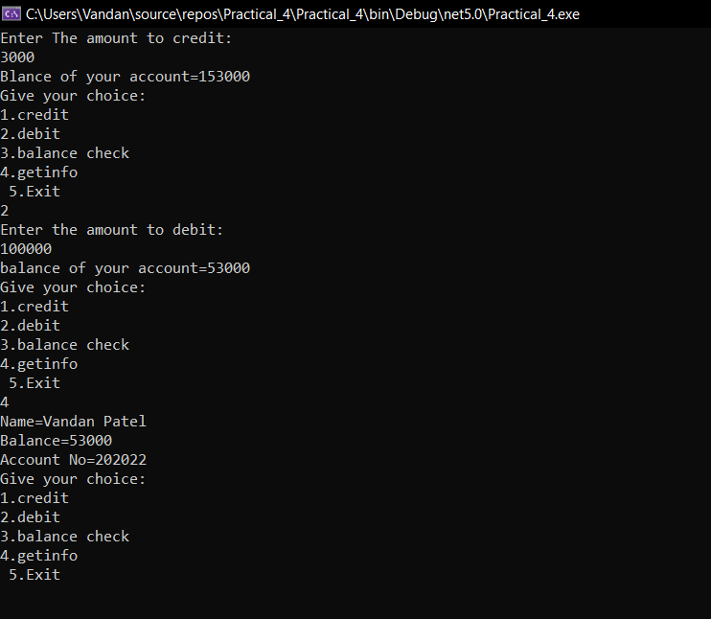

1. Write a program to find frequency of each element in an array using command Line Arguments.

**Code:**

using System;

using System.Collections.Generic;

using System.Linq;

using System.Text;

using System.Threading.Tasks;

namespace Practical_4

{

class second

{

static void Main(string[] args)

{

int i, j, count;

int[] b = new int[10];

Console.WriteLine("20012011130_Patel Vandan");

Console.WriteLine("Enter the elements of the Array :: ");

for (i = 0; i < 10; i++)

{

Console.WriteLine(args[i]);

b[i] = -1;

}

for (i = 0; i < 10; i++)

{

count = 1;

for (j = i + 1; j < 10; j++)

{

if (args[i] == args[j])

{

count++;

b[j] = 0;

}

}

if (b[i] != 0)

{

b[i] = count;

}

}

for (i = 0; i < 10; i++)

{

if (b[i] != 0)

{

Console.WriteLine("{0} occurs at {1} times.", args[i], b[i]);

}

}

Console.ReadKey();

}

}

}

**Output:**

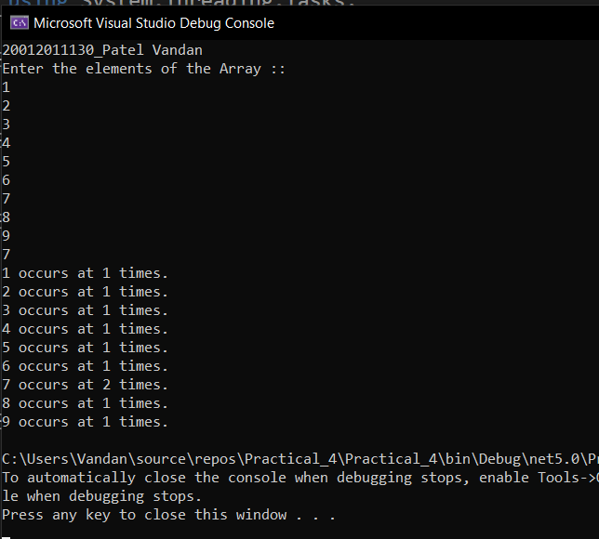

1. Write a program to explain StringBuilder Class. [Note: Use Append(), AppendFormat(), Insert(), Remove(), Replace() Methods.]

**Code:**

using System;

using System.Collections.Generic;

using System.Linq;

using System.Text;

using System.Threading.Tasks;

namespace Practical_4

{

class third

{

static void Main(string[] args)

{

Console.WriteLine("20012011130_Patel Vandan");

String v = "Nandan";

StringBuilder sb = new StringBuilder(v);

//Replace

Console.WriteLine("Replace: Nandan");

sb.Replace("N", "V");

Console.WriteLine(sb);

//Append

Console.WriteLine("Append: ");

sb.Append(" Patel");

Console.WriteLine(sb);

Console.WriteLine("Remove");

sb.Remove(0, 6);

Console.WriteLine(sb);

Console.WriteLine("Insert:");

sb.Insert(0, "Mr");

Console.WriteLine(sb);

//Use appendFormat

String[] a = { "GUNI", "UVPCE", "CE", "IT" };

int counter = 0;

StringBuilder b = new StringBuilder();

foreach (String value in a)

{

b.AppendFormat("You have visited {0} {1}\n", counter++, value);

}

Console.WriteLine(b);

Console.ReadKey();

}

}

}

**Output:**

